Chairman Mr Tom Spink

Chief Executive Professor Lesley Dwyer

Advanced Training speciality module ERCP
(STR 6+ in GASTROENTEROLOGY

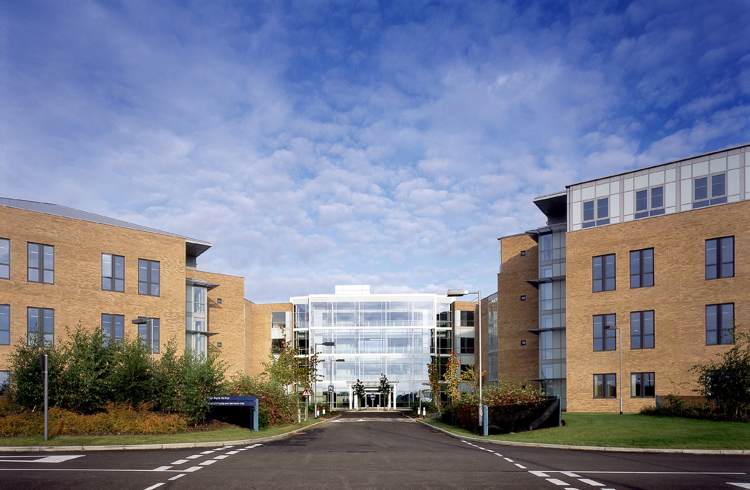

DEPARTMENT OF GASTROENTEROLOGY

NORFOLK AND NORWICH UNIVERSITY HOSPITALS NHS FOUNDATION TRUST
April 2024

NORFOLK AND NORWICH UNIVERSITY HOSPITALS NHS FOUNDATION TRUST

ATSM ERCP in Gastroenterology

The Norfolk and Norwich University Hospital Trust are looking to appoint a Senior Clinical Endoscopy Fellow to further develop their expertise in specialist endoscopy.
ERCP and EUS are performed largely in our current inpatient facility at The Norfolk and Norwich University Hospital Trust as opposed to our offsite facility in our brand new Quadram Unit which is a state of the art ten roomed endoscopy department within a scientific and clinical research trials institute.
This position would allow an advanced training Fellow to develop expertise in advanced endoscopy, and specifically ERCP and/or EUS. We would hope that the advanced training fellow will perform more than 300 ERCPs over the twelve month period and trained to independent practice by the end of this time. We would be looking to provide a minimum of 6 ERCP/EUS training lists per week, attendance at the HPB MDT and running a preassessment/planning clinic for ERCP patients.
This position may also include sessions of service which will be performing GI inpatient emergency endoscopy and attending specialist MDTs and providing limited clinic provision.

We welcome all applications irrespective of age, disability, gender, sexual orientation, race or religion. Additionally, people with disabilities will be offered an interview providing they meet the minimum criteria for the post. The Trust operates job share and flexible working.

DUTIES OF THE POST

The appointment is to the Trust, not to specific hospitals.

Undertake specialist training in complex therapeutic endoscopy

Attend specialist MDTs

Provide inpatient endoscopy cover

Provide inpatient ward cover and oncall when ward is short staffed

Proposed job plan

 | Mon | Tue | Wed | Thurs | Fri
AM | ERCP/therapeutic endoscopy (or EUS) | ERCP (JPH/QEHKL) (or EUS) | HPB cancer MDT  HPB Benign MDT | ERCP | ERCP (JPH/QEHKL)
Educational opportunities (lunch) | Grand round | Liver teaching | XR/Pathology Meeting | IBD teaching/MDT | Upper GI MDT
PM | ERCP | Audit/Research/  Vetting | ERCP preassessment | ERCP | ERCP

THE SPECIALTY

Full Time Consultant staff and special interests

- Dr Richard Tighe – Service director endoscopy, director of East of England Endoscopy Training Academy, screening colonoscopy, endoscopy training, therapeutic endoscopy, IBD, ERCP
- Dr Mark Tremelling (incoming gastroenterology service director) – IBD genetics, clinical IBD, diagnostic and therapeutic colonoscopy
- Dr Anupama de Silva – IBD lead, IBD, therapeutic endoscopy, endoscopy training
- Dr Martin Phillips – hepatology, ERCP, therapeutic endoscopy
- Dr Arun Shankar – (outgoing Service Director) hepatology, transplant medicine, endoscopy,
- Dr Syed Alam - hepatology, transplant medicine, endoscopy
- Dr Simon Rushbrook – hepatology, PSC genetics, endoscopic ultrasound, ERCP, hepatobiliary medicine and liver transplantation
- Dr Marianna Mela – (incoming gastroenterology service director) Autoimmune liver disease and metabolic liver disease
- Dr Simon Chan - clinical IBD, diagnostic and therapeutic colonoscopy
- Dr Dana Ismail – Specialist nutrition and Intestinal failure physician
- Dr Charlotte Pither – Specialist nutrition and intestinal failure physician
- Dr Bernard Brett – Complex therapeutic endoscopy and bowel screening endoscopist.

Part Time Consultant Medical Staff
- Dr Ian Beales (UEA senior lecturer) – dyspepsia, medical education, clinical trials, acid-peptic disorders, IBD
- Dr Andrew Douds – endoscopy, IBD
- Dr Leo Alexandre Senior lecturer, UGI cancer, endoscopy

Non Consultant Career Grade
- Dr Jean-Paul Cannon (Clinical Fellow)

Junior doctors
- 4 Gastroenterology specialist registrars
- 3 CT1 trainees
- 4 FY1 trainees

Technical and other Support Staff

- Tracy McDonnell (Senior Sister Endoscopy)
- Virginia Lopez-Selfa (Nurse Endoscopist)
- Yuri van Pieterman (Nurse Endoscopist)
- Ann Smith (Nurse Endoscopist)
- Harriet Smith (Nurse Endoscopist)
- Sara El Salamani (Nurse Endoscopist)
- Mioara Jackson (nurse endoscopist)
- Tanya Chapman (Hepatology Nurse Specialist)
- Heather Simpson (IBD Nurse Specialist)
- Lyndsey Thorpe (IBD Nurse Specialist)
- Ann-Marie Cook (part-time Nutrition Nurse Specialist)
- Donna Wainman (part-time Nutrition Nurse Specialist)

THE DEPARTMENT

The Norfolk and Norwich University Hospital serves a population of 750,000. We are the busiest endoscopic department in the UK

Endoscopy

In 2018 we opened the Quadram Institute which houses our brand-new state of the art 10 roomed endoscopy unit. The Quadram Institute hosts the East of England Endoscopy training academy, which Dr Richard Tighe directs.

This is a world-class institute for teaching and training and research in endoscopic care and underpins the NNUH GI Biorepository. Of course, as a gastroenterologist joining the team part of your work will be undertaken in this new institute and will give you an opportunity to develop and establish your own academic profile within the department.

This 10-roomed unit will be in conjunction with a 3 roomed endoscopy unit in the NNUH for interventional and inpatient work.

Our unit provides a full range of diagnostic and therapeutic endoscopy including therapeutic gastroscopy, upper GI EMR and RFA for Barretts, ERCP, spyglass cholangioscopy, radial and linear endoscopic ultrasound, enteroscopy, PEG insertion, PEC insertion, oesophageal, duodenal and colonic stenting and a capsule endoscopy service, along with a complex regional polypectomy service.

The unit has recently had its JAG accreditation renewed. The lead assessor said: “The new endoscopy environment is a modern state-of-the-art facility that is perhaps the best I have seen to date. The careful design supports not only an exceptional patient experience but is also a unique and exceptional place for staff to work in. It’s a centre to be very proud of and the endoscopy leadership team is congratulated on not just the design, but the hard work put into considering every aspect of the process.”

Our consultant team is supported by 6 established nurse endoscopy posts, and we are currently training a further 4. We believe that a modern unit will be a mixture of nurse and consultant endoscopists working alongside each other delivering diagnostic and interventional work.

Dr Tighe oversees our endoscopic trainees and ensures that as a department through audit that each individual is adhering to JAG KPIs and standards.

The endoscopy unit is home to the JAG endoscopy training centre running monthly courses from basic skills in OGD and colon, to animal polypectomy courses and Train the Trainer courses. Dr Ian Beales is the JAG training centre lead.

Norwich also hosts the East of England Endoscopy Training academy for which Dr Richard Tighe is the academic clinical lead. The academy is a regional training model based upon a hub and spoke units, with other immersive training sites in Addenbrookes, ESNEFT, Bedford, Basildon, West and East Herts. The academy is at the forefront in the UK for accelerating training of specialist trainees through the adoption of an immersive training model which has been very successful. The endoscopy fellow would be expect to help with training and the running of courses.

The Gastroenterology Department

The GI department is divided into 3 sub-specialist inpatient teams comprising: Inflammatory Bowel disease/Luminal GI disorders/Therapeutic Endoscopy; Clinical nutrition/Luminal GI disorders/therapeutic endoscopy; and Hepatobiliary medicine and Hepatology. Successful applicants will join the most appropriate team and we welcome full time and part time applicants for these positions.

We have an active inflammatory bowel disease interest. We run a large weekly specialist IBD clinic. We have weekly joint gastroenterology and radiology x-ray meetings, a dedicated monthly IBD MDT, a monthly virtual biologics clinic, a monthly histopathology meeting and a joint surgical IBD clinic. We provide a regional service for complex IBD patients. 5 specialist nurses arrange biologic therapy, intravenous iron infusions and man an IBD helpline. We actively recruit patients for both interventional and observational clinical research projects and have strong research links to academics at the adjacent University of East Anglia.

The department has a dedicated multidisciplinary clinical nutrition service. An out-patient nutrition clinic occurs weekly on Wednesday morning and is attended by all disciplines except the pharmacist. All out-patient referrals for PEG/RIG are seen here prior to booking their procedures. Home care support and tuition are delivered before PEG/RIG, to minimise the length of hospital stay. At present patients on Home Parenteral Nutrition are managed and have dedicated admission to the specialist ward (Guist) if in-patient care is needed. This service is provided to patients from Norwich and also to those in the catchment areas of Queen Elizabeth Hospital, King’s Lynn, James Paget Hospital, Great Yarmouth and the Ipswich Hospital (total population1.5 million). The team provides extensive educational support to patients and other health care professionals.

The department has been at the forefront of the national colorectal cancer screening programme. We were in the first wave of centres to start the programme in 2006 and were also first to pilot the extension of this programme to the 70–75-year-old age group in July 2008. We were also one of the first wave of centres performing bowel cancer screening flexible sigmoidoscopy in 2013. We are a leading national endoscopy training centre with courses every month. These include basic skills endoscopy courses, animal model polypectomy courses and teaching the teachers courses. A successful applicant would be welcomed to contribute to these.

The clinical hepatology team currently is composed of 5 consultants. The core team is supported by consultant colleagues in Interventional Radiology, Clinical Biochemistry and Microbiology/virology, histopathology and by hepatobiliary radiology (led by Dr Benedict Simpson).

The hepatology team offer a wide range of specialist clinics dedicated to hepatobiliary cancer, viral hepatitis, PSC, autoimmune liver disease, alcohol and NAFLD. This is in addition to specialist liver transplantation clinics in conjunction with our colleagues at Addenbrookes Hospital and a range of general liver clinics.

The team has excellent working relationships with the Cambridge liver unit and work closely with our colleagues in the management of patient’s pre and post liver transplantation. We are part of the regional HCV service providing DAA drugs to patients with HCV infection according to operational managed network.

Virology, histopathology and interventional radiology support are excellent. Percutaneous biliary and duodenal stents, embolization procedures, RFA and transjugular liver biopsies are available. Trans-arterial chemoembolization, and radiofrequency ablation therapy are also available for hepatocellular carcinoma cases. We are aiming to commence a TIPSS service imminently and have a number of fibroscan clinics running alongside MRE for fibrosis assessment.

The service has 4 dedicated liver nurses working within it supporting the care of patients from a range of liver sub-specialty clinics.

EDUCATION and TRAINING IN THE DEPARTMENT

There is a weekly Wednesday lunchtime departmental meeting – once a month this is a histopathology meeting, the other weeks a radiology meeting (also attended by upper and lower GI surgeons). We run weekly teaching sessions for junior doctors in the department chaired by a consultant. There is an active audit programme including many audits required for the Global Rating Score as well as regular audits on sedation practice and patient satisfaction. The appointee is expected to participate in audit and the production of medical guidelines for the department. There is a monthly half day clinical directorate and clinical governance meeting including morbidity & mortality and patient safety discussions.

All trainees have an educational supervisor from the consultant staff. Medical students from the University of East Anglia attend the department as part of the Digestion module. We have had excellent feedback from previous cohorts of students. All consultants in the department have the opportunity to contribute to the teaching of these students on the ward, in clinic, in the endoscopy unit or via lectures/seminars.

Academic Gastroenterology and the Norwich Research Park

The Norwich Medical School within the University of East Anglia and the Norfolk and Norwich University Hospitals NHS Foundation Trust (NNUH) are both members of an overarching entity the Norwich Research Park (NRP) which has biomedical science as its major driver and as a deliverable. Aside from the NNUH and UEA, the Norwich Research Park includes the Sainsbury Laboratory, and 3 Institutes supported the Biotechnology and Biological Sciences Research Council (BBSRC) - namely the Quadram Institute that has the Quadram Biosciences, the John Innes Centre (JIC) and the Earlham Institute (a genome analysis centre). All of these are within 12 minutes-walk of each other, facilitating close working relationships and networking. As already mentioned, the new endoscopy centre is in the newly built Quadram centre.

The scientific research of the members of the Norwich Research Park (NRP) potentially has great relevance to gastroenterology. The BBSRC’s John Innes Centre is a world-leader in plant science and microbiology with research programmes including antibiotic discovery and the development of new plant strains to promote human health. Research at the Quadram is aimed at harnessing food for health and the prevention of food-related diseases and is led by 25 Principal Investigators. The microbiome and food-borne pathogens and major research themes within its research programme. UEA is one of the few universities in the UK to have a germ-free animal unit. Across the NRP facilities are available for analysis of gut microbiota, genome analysis, DNA sequencing and associated bio-informatics and mathematics and a single cell sequencing unit. Current gastroenterology research focuses on intestinal inflammation and the interaction of the gut microbiome, intestinal epithelial cells, and mucosal immune system. Key areas of research interest are: Inflammatory bowel disease, PSC, enteric infection, intestinal epithelial cell death, microbial host interactions in the gut, autophagy, dietary risk factors for gastrointestinal disease and organoids models of disease.

Academic Researchers

- Dr Ian Beales
- Professor Simon Carding
- Dr Simon Chan
- Dr Lindsay Hall
- Prof Uli Meyer
- Dr Penny Powell
- Dr Stephanie Schüller
- Dr Ailsa Welch
- Professor Tom Wileman
- Dr Simon Rushbrook

APPENDIX 1

CONTACTS FOR FURTHER INFORMATION

Candidates requiring further information are invited to contact the following:

1) Dr Richard Tighe
Head of Endoscopy
Norfolk and Norwich University Hospital NHS Trust
Colney Lane
Norwich
NR4 7UY

email richard.tighe@nnuh.nhs.uk

- Dr Mark Tremelling
Service Director
Department of Gastroenterology
Norfolk and Norwich University Hospital NHS Foundation Trust
Colney Lane
Norwich
NR4 7UY

email mark.tremelling@nnuh.nhs.uk

- About the Trust

The Norfolk & Norwich University Hospital NHS Foundation Trust (NNUH) is one of the busiest teaching trusts in England. We serve over 900,000 people across Norfolk, North Suffolk and surrounding areas for specialist services. In 2016/17 our 7,500 members of staff delivered 816,000 outpatient appointments, 90,000 day cases and 90,000 inpatient admissions from our two hospitals.
- The Norfolk and Norwich University Hospital is located on the Norwich Research Park and serves the population of Norfolk and Norfolk Suffolk and further afield for specialist services. It opened in 2001 and is a 1,200 bed teaching hospital with state-of-the-art facilities. We provide a wide range of secondary and tertiary services, including Accident and Emergency. The trust will be commemorating 250 years of a hospital in Norwich in 2021.
- Cromer and District Hospital is located in Cromer on the North Norfolk coast and serves the North Norfolk population. It was redeveloped in 2012 to replace the 1930s-founded hospital. We provide a wide range of consultant-led outpatient services, day case operations and a Minor Injuries Unit (MIU). The trust commemorated 150 years of a hospital in Cromer in 2017/18.

Our vision is to ‘provide every patient with the care we want for those we love the most’, Our PRIDE values support our vision and guide the behaviour of everything we do.

- People-focused: We look after the needs of our patients, carers and colleagues, to provide a safe and caring experience for all.
- Respect: We act with care, compassion and kindness and value others’ diverse needs.
- Integrity: We take an honest, open and ethical approach to everything we do.
- Dedication: We work as one team and support each other to maintain the highest professional standards.
- Excellence: We continuously learn and improve to achieve the best outcomes for our patients and our hospital

Our strategy, agreed in 2016, is based on four key objectives:
- We will be a provider of high-quality healthcare to our local population
- We will be the centre for complex and specialist medicine for Norfolk and the Anglia region
- We will be a recognised centre for excellence in research, education and innovation
- We will be a leader in the redesign and delivery of health and social care services in Norfolk.

Our clinical services are structured across four divisions offering a wide range of careers to new staff of all disciplines. Our four divisions are Medicine, Surgery, Women’s and Children’s, and Clinical Support Services. We always strive to hit the highest standard in each of these areas, including pioneering treatments and the best career development for employees. In addition, the Trust provides a full range of more specialist services such as Oncology and Radiotherapy, Neonatology, Orthopaedics, Plastic Surgery, Ophthalmology, Rheumatology, Paediatric Medicine and Surgery.

- Medicine is comprised of Cardiology; Respiratory Medicine; Stroke; Nephrology; Gastroenterology; Allergy; Older People’s Medicine; Endocrinology; Neurology; Rheumatology; Emergency and Acute Medicine; Oncology, Palliative Medicine and Haematology.

- Surgery consists of General and Thoracic Surgery; Dermatology; Urology; Head and Neck; Ophthalmology; Orthopaedics; Plastic Surgery; Anaesthetics, Critical Care, Pain Management, Sterile Services, Theatres and the Day Procedure Unit.

- Women’s and Children’s Services consists of Obstetrics; Gynaecology; Paediatric Medicine; Paediatric Surgery and Neonatology.

- Clinical Support is comprised of Nuclear Medicine; Cellular Pathology; Laboratory Medicine; Therapeutic and Support Services; Radiology; Pharmacy; and Health Records.

We want to recruit people who are looking for new challenges and opportunities, share our values and want to be part of our vision to provide every patient with the care we want for those we love the most.

The Faculty of Medicine and Health Sciences (FMH)
The Faculty of Medicine and Health Sciences is led by the Pro-Vice-Chancellor of Medicine and Health Sciences, Professor Dylan Edwards, working closely with the Heads of School, and the Associate Deans who share responsibility for the areas of Research; Enterprise and Engagement; Learning and Teaching; Admissions; and Postgraduate Research. These senior academics, together with the Senior Faculty Manager, the Faculty Human Resources Manager, and the Faculty Finance Manager, form the Faculty Executive. Teaching is organised through the Faculty’s two Schools of study, comprising Health Sciences and Norwich Medical School, assisted by a Centre for Inter-professional Practice.

The School of Health Sciences
On 1st August 2014, the Schools of Nursing Sciences and Rehabilitation Sciences at the University of East Anglia (UEA) came together to create a new School of Health Sciences. The School’s purpose is to resolve health challenges through the advancement of knowledge and interdisciplinary working. This innovative development has built on the strong reputation of the two Schools and creates an outstanding learning environment for students; fostering cutting edge research and offering opportunities for real innovation in enterprise development.

The School of Health Sciences encompasses a family of interrelated disciplines; midwifery, all fields of nursing, operating department practice, paramedic science, physiotherapy, occupational therapy and speech and language therapy. Research is focused on developing solutions to future global health challenges, which may arise as a consequence of our life style choices (e.g. obesity, diabetes); living longer with long term conditions and the need for systems, services and training models to adapt to different health care needs in the future.

The school has a clear vision and strategy to be a leading international academic force, improving the quality of healthcare through research and education. The School’s academic structure is designed to secure the delivery of this strategy. Staff belong to one of three health challenge units which drive innovation in research, teaching and learning in three theme areas: reforming health systems; promoting family and community health and living well with long term conditions. The groups foster a collaborative ethos and serve as an academic ‘home’ community for those with related interests from a variety of professional backgrounds.

There are currently have over 1300 undergraduate, pre-registration students and around 1200 post registration and postgraduate students taking a variety of modules and courses, including the flagship NIHR Masters in Clinical Research. The success of the School is reflected by the popularity of its programmes and a number of measures of esteem. The School is ranked 5th for nursing and midwifery and 7th for health professions in the Guardian University Guide (2015) and has recently climbed four places to 8th place for nursing in the Complete University Guide (2015).

The Norwich Medical School
The Norwich Medical School was established at UEA in 2001 and has over 200 members of academic, research and support staff – and a large number of active NHS secondees and honorary appointees – from a wide range of disciplines (including medical specialties, biological sciences and a range of social and statistical disciplines, including health economics, clinical psychology, epidemiology and medical statistics). The School has grown with a current entry each year of 168 students. Its first students graduated in 2007 and since then the School has been in the top 10 of all medical schools on the National Student Survey on three occasions, the Prescribing Skills Assessment pass rate is over 97%; the Situational Judgement Test is among the top scores nationally and the Preparedness to Practice and Core Skills Acquisition are consistently top 5. In 2014, 2015 and 2016 the school was shown to have produced some of the best prepared Foundation doctors, demonstrated through national data provided by the GMC following their annual survey of all doctors in training.

The Schools’ research focus is on developing translational research themes that answer important health questions, from an understanding of the basic mechanisms and genetics of disease through to clinical trials and from there to incorporation into clinical guidelines and evaluation within the broader health care community.

The Medical School has a vision to build a clinical and translational research programme of international standing based on the existing strengths of the Medical School, UEA, The Norfolk and Norwich University Hospital and the Norwich Research Park. The presence of three BBSRC research institutes on the Norwich Research Park (Institute of Food Research, John Innes Centre, The Earlham Institute (formerly the Genome Analysis Centre or TGAC) provides unique opportunities not available to other comparable medical schools and in 2018 the Quadram Institute also opened its doors. Preventive medicine is a major goal for 21st century medicine. The role of diet in the prevention of a wide spectrum of disease will be a particular focus of research within the Medical School. Incorporated with this will be parallel strategies to understand the epidemiology and health economic impact of the conditions studied.

Areas of research within the Medical School include:
- Cancer Studies
- Clinical Science and Trials
- Dementia
- Epidemiology
- Gastroenterology and Gut Biology
- Health Economics
- Health Services Research
- Medical Microbiology
- Musculoskeletal Science
- Nutrition
- Psychological Sciences

Norwich Medical School is housed on East (main) campus in the Norwich Medical School Building, and on West Campus in the new £20m Bob Champion Research and Education Building, which opened in late 2014, adjacent to the Norfolk and Norwich University Hospital, providing outstanding facilities for staff and supporting clinically orientated research.

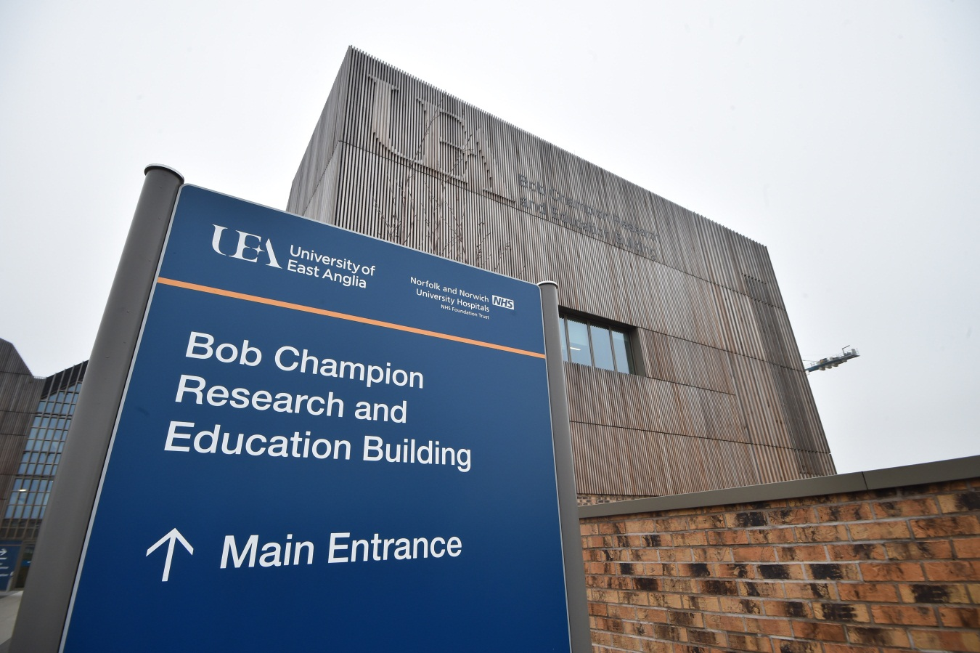

Norwich Research Park
The Norwich Research Park is a partnership between the NNUH, UEA and four independent world-renowned research institutes, namely the John Innes Centre, Quadram Institute Bioscience and The Genome Analysis Centre (all strategically funded by the Biotechnology and Biological Sciences Research Council (BBSRC) and The Sainsbury Laboratory to the Gatsby Charitable Foundation. The BBSRC is itself a partner as is the John Innes Foundation.

The Norwich Research Park is home to around 30 science and IT based businesses. With over 11,000 people including 2,700 scientists and annual research spend of over £100 million; the Norwich Research Park is Europe’s leading centre for research in food, health and the environment.

The main strength of Norwich Research Park is the concentration of world-leading scientists coupled with the capability for multidisciplinary research. The vision of the Norwich Research Park partners and local government stakeholders is to develop a thriving science and innovation business park over the next decade by supporting spin-out and start-up companies and through attracting inward investment from large corporate organisations involved in science and technology.
Norwich Research Park aims to deliver solutions to the global challenges of healthy ageing, food and energy security, sustainability and environmental change.

It is an international centre of excellence in life and environmental sciences research with world-class expertise in the research and development pipeline from genomics and data analytics, global geochemical cycles and crop biology, through to food, health and human nutrition.

Our science transcends conventional boundaries by forging interdisciplinary links, thereby driving innovation, enterprise and promoting economic growth, and particularly underpinning a new bioeconomy.

Quadram Institute
The Quadram Institute is the name of the new centre for food and health research located at the heart of the Norwich Research Park, one of Europe’s largest single-site concentrations of research in food, health and environmental sciences. The new £81.6m facility to house the Quadram Institute opened in 2018.
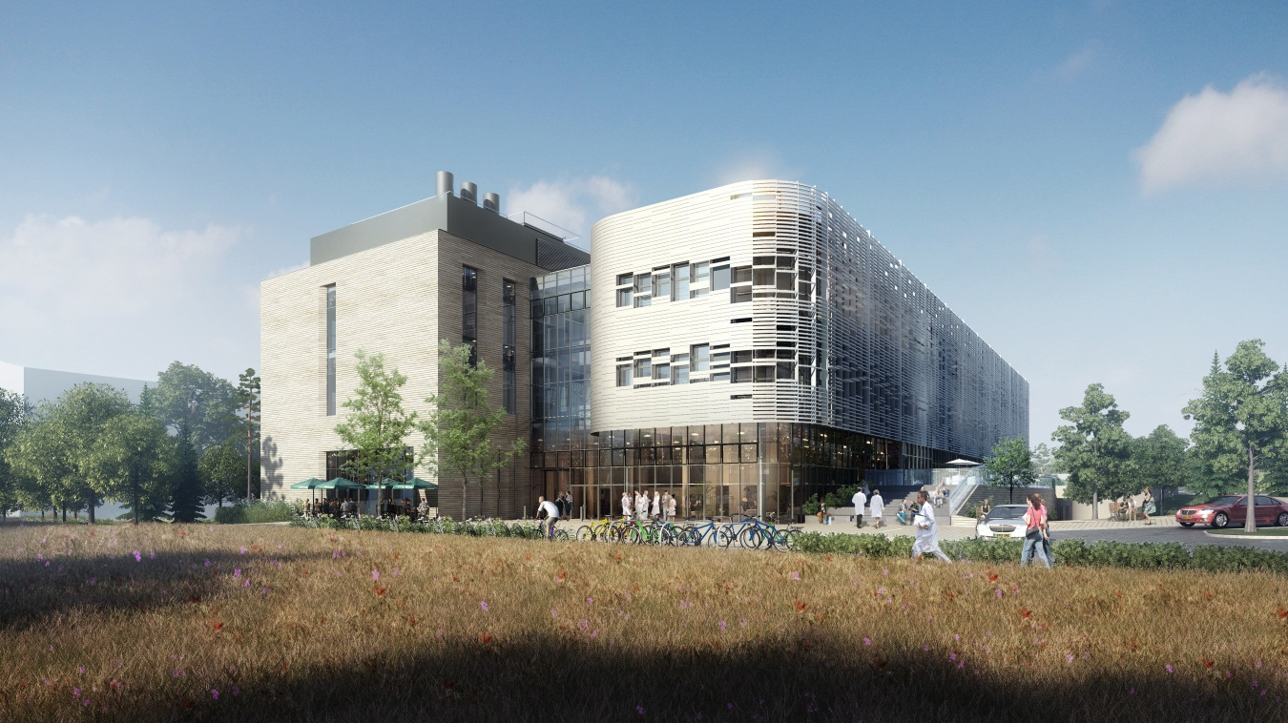
The new world leading centre for food and health research will bring together the Institute of Food Research, the NNUH’s regional gastrointestinal endoscopy facility and aspects of the UEA’s Norwich Medical School and the Faculty of Science.
Due to population expansion combined with people living longer and the need to screen a broader age range for diagnostic and potential preventative reasons the NNUH will be doubling its capacity for bowel screening.
The dedicated unit and world leading research facilities is located in the Quadram Institute. The Quadram Institute’s mission is to develop solutions to worldwide challenges in human health, food and disease. The concept for the institute is to enable a step-change in food and health science research by providing new insights and accelerating innovation that will deliver new foods and treatments as well as proactive health and lifestyle interventions, for the benefit of society and the bio-economy.
Its creation underlines the collaboration of the four founding partners and reflects its strategy to work across four research themes: the gut and the microbiome (the gut flora); healthy ageing; food innovation; and food safety. These research themes will link closely to the world-class plant and crop research at the John Innes Centre and bioinformatics at The Genome Analysis Centre, both also located at the Norwich Research Park, creating a powerful plant-food-health pathway to deliver clinically-validated strategies to improve human nutrition, health and wellbeing. The Quadram Institute will work closely with the food industry, healthcare and allied sectors to transfer its scientific knowledge into practice.

Norwich Radiology Academy
The Trust is home to the Norwich Radiology Academy, run on behalf of the Department of Health and Royal College of Radiologists. The academy, one of only three in the country, is also located on the Norwich Research Park in the Trust’s Cotman Centre and provides a groundbreaking approach to radiology training in the UK.

Education and Training

The Trust has an outstanding reputation for providing a good quality education and excellent clinical experience for trainees. The large catchment population provides a wealth of clinical material. Most departments have well-developed in-house teaching programmes and there are many examples of locally developed skills courses including Basic Surgical Skills, MRCS training and Minor Surgical Skills courses as well as more specialised courses such as for the FRCS (Orth). There is an established system of educational supervision and assessment for Foundation Programme and Core Training.

The Trust has one of the best-equipped Postgraduate Centres in the country. There is an excellent lecture theatre and library as well as seminar rooms and clinical skills laboratories within the Centre which is currently situated within the Hospital and in the new Bob Champion Research and Education Building.

There are opportunities for trainees to do an MSc in Health Sciences with the University of East Anglia. A diploma in clinical skills is being developed in collaboration with the University, aimed at the Core Training grade. There is an excellent local GP VTS scheme and this, and good quality educational programmes in NANIME, provide strong links with local GPs. For all these reasons Norwich is able to attract good quality candidates to fill training posts and eliminate many of the problems of recruiting into shortage specialties.

The Trust provides individual consultants with a budget to support additional training and CPD. A large number of consultants have active involvement in external College, regional or national activities.

Research and Development
The Trust encourages all consultants to become involved with research. This is facilitated by the proximity of the Norwich Research Park.

There is a joint UEA and NNUH Chief of Research & Innovation and a joint research office which currently monitors nearly 200 new research applications per year. There is a Clinical Trials Unit based partly in the hospital and partly at the University. The Trust hosts the Clinical Research Network: Eastern (CRN). Our recruitment to clinical trials is consistently above target.

GENERAL CONDITIONS OF APPOINTMENT

The Trust requires the successful candidate to have and maintain full registration with the General Medical Council, NHS Indemnity and private cover if appropriate. The appointee is advised to maintain membership of a Medical Defence Organisation for professional duties not included within the NHS Indemnity Scheme.

Consultants are required to have continuing responsibility for the care of patients in their charge and for the proper functioning of their departments. They are expected to undertake administrative duties that arise from these responsibilities. Specifically, Consultants will co-operate with the Clinical Directors to ensure timely and accurate production of discharge letters and summaries of patients admitted under their care. "Timely" will, as a minimum, be the meeting of standards agreed between the Trust and the Purchasers.

The successful candidate will normally be required to reside within 15 miles of the main hospital base or 30 minutes travel time.

The appointee will be accountable managerially to the Clinical Director and the Chief Executive, and professionally to the Medical Director of the Trust.

The main terms and conditions of employment relating to this appointment will be those set out in the national handbooks of the Terms and Conditions of Service of Hospital Medical and Dental Staff and, as appropriate, of the General Whitley Council. Consultants will normally be appointed on the bottom of the consultant salary scale except where they have recognised seniority at a consultant level.

The appointee may be required to undergo a medical examination prior to appointment and will be required to attend the Occupational Health Department within one month of commencement. She/he will also be required to comply with the Trust's policies and procedures concerning Hepatitis B, details of which will be supplied to candidates shortlisted for posts that would involve exposure prone procedures

The post is exempt from the provisions of section 4(2) of the Rehabilitation of Offenders Act 1974 by virtue of the Rehabilitation of Offenders Act 1974 (Exceptions) Order 1975. Applicants are, therefore, not entitled to withhold information about convictions, which for other purposes are "spent" under the provision of the Act, and in the event of employment any failure to disclose such convictions could result in dismissal, or disciplinary action by the Trust. Any information given will be completely confidential and will be considered only in relation to an application for positions to which the Order applies.

In accordance with the Protection of Children Act 1999, Criminal Justice and Court Services Act 2000 and Care Standards Act 2000 (Part VII – Protection of Vulnerable Adults, the Trust has a legal duty to safeguard children and vulnerable adults in its care from the potential risk of associating with persons with previous convictions involving children and vulnerable adults. In order to carry out checks on those persons having access to children and vulnerable adults, the Trust will use the Criminal Records Bureau (CRB) disclosure service. The Trust therefore requires all medical staff successful at interview to complete and submit a Disclosure Application Form, and any offer of employment will be subject to a satisfactory Enhanced Disclosure check being returned from the CRB.

It is essential that all Trust employees adhere to, and follow good infection control practices, as detailed in the Trust’s Infection Control Manual and other related policies and guidelines

All Trust staff have a statutory duty to safeguard children in their care and promote the welfare of children and young people. Staff are expected to know about the Trust’s safeguarding procedures which can be found on the intranet. Staff must be familiar with the signs and symptoms of abuse and know what to do if any such concerns are raised.

The Trust is a no smoking hospital and smoking is not permitted on any of the Trust’s premises.

