ENDOSCOPY TRAINING AT KAMUZU CENTRAL HOSPITAL (KCH) ENDOSCOPY UNIT - LILONGWE-BLACKPOOL ENDOSCOPY LINK May 11th-15th 2015

**Supported by Grant from the British Society of Gastroenterology**

Visiting team

Dr M T Hendrickse , Consultant Gastroenterologist Blackpool NHS Foundation trust(MH) visiting trainer

Local Team

Dr Sven Young visiting Surgeon and advisor on ITU, HDU and Endoscopy unit restructuring

Dr Leonard Banza – orthopaedic surgeon and Training Lead for surgical registrar /resident programme

Dr Chang Miao ( KCH endoscopist, general surgeon)

Dr Gift Mulima (GM) senior resident registrar, surgical endoscopist and local training lead (GM)

Zenith Phambala ( endoscopy nurse)

Joseph Banda (endoscopy nurse)

Kataza Botha Ngwira ( endoscopy nurse)

( Dr Carlos Varela , Head of Department , was unavailable at the time of the visit)

Trainees

Dr Enock Ludzu(EL) surgical resident

Dr Chifundo Kajombo(CK) surgical resident

Dr Vanessa Msosa surgical resident

Dr Judith Mkwaila Surgical Resident

Previous visits by MH and other colleagues had established an endoscopy training programme at Kamuzu Central Hospital( see previous reports on visits in 2013, 2014 and presentation at Annual British Society Of Gastroenterology meeting June 2013 .)

Basic skills and enhanced /refresher courses have been run with MH as a visiting trainer with Gift Mulima as a fully trained local endoscopist and trainer

It was recognised that in order for the endoscopy service to expand, there is a requirement to develop further trainees to become independent endoscopists and potential trainers .

In addition , it was recognised that the endoscopy unit needs further technical support , due to old endoscopes now malfunctioning and restructuring of the unit with a new rebuild

Aims of current visit

1. To assess endoscopy training requirements of current trainees at Kamuzu central hospital.
2. To assesse /support current trainees with endoscopy experience with a refresher/ enhanced course
3. Evaluate the current endoscopy service at Kamuzu central hospital , and the progress in development of a new endoscopy unit as part of the restructuring of ITU, HDU services at Kamazu central hospital
4. Through separate funding MH has purchased an Olympus stack and two 260 series scopes ( gastroscope and colonoscope ) which was being delivered by freight through Glasgow council.

**KCH Endoscopy Unit**1

1 ) Through Norwegian Support and funds , a major restructuring and rebuild of ITU , HDU and the endoscopy unit is taking place , with the new build at an advanced stage. This comprises a designated spacious endoscopy room , recovery area, sluice and decontamination/scope cleaning area and patient waiting area. While this is being developed , endoscopy has continued in the theatre in accident and emergency. The room is more spacious than previously, although the scope cleaning area and sink are in the same room, which is quite cluttered , with no designated patient waiting area( they wait in the adjacent general corridor). Currently there are three regular endoscopy lists per week ( about 10 patients per list) performed predominantly by Dr Gift Mulima(GM) , Enoch Ludzu and Chifundo Kajombo, with some support from Dr Miao. Dilatation, stenting and banding is regularly performed mainly on GM s list. It is recognized that there is a need for more endoscopy lists. This will require more independent endoscopists and trained nursing staff and increased capacity.It is expected that the new unit will be functional in the next three months

2) Cidex OPA is now regularly available , with good contacts with hospital pharmacy for supplies

3) after the last visit , MH and local consultants put forward a proposal to obtain oesophageal stents through United Nations funding This has been successful with over 70 stents supplied to KCH and similar number to Blantyre. Stentng is now regularly performed at KCH

Endoscopy Equipment

1. Currently the unit regularly uses an old fibreoptic Pentax gastroscope and old Pentax videogastroscope. The previous 2 european Olympus 100series gastroscopes are no longer functional .
2. The unit was donated a Storz gastrosope and colonoscope. The gastroscope has recently been damage d by ? water contamination, , the colonoscope is still functional
3. two fully operational duodenoscopes, 1 fibreoptic Olympus , and one pentax video duodenoscope( donated by Pentax UK) , with biliary stents , balloons , wires, sphincterotomes are also available
4. MH delivered 12 colonic /duodenal stents, 15 – 20 banding kits, bougies and TTS balloons also delivered
5. Brushes and wires
6. The lack of functioning videoendoscopes was highlighted to MH , who personally purchased a used ( and fully operational) olympus stack and 3 endoscopes ( 2 gastroscopes , and 1 colonoscope ) . One gastroscope was delivered by MH. Glasgow council kindly arranged transport of the stack and other endoscopes by freight. At the time of the visit this equipment had still not been delivered to KCH, having been held up by the Malawi Revenue authority.

MH had discussions with the Hospital Director Dr Ngoma , who has written in support of Glasgow council, to have this and other supplies released. At the end of the visit, it appears the equipment will be released shortly.

1. MH has expressed concern with the team at the water contamination of scopes: It is noted that the endoscopy nurses have attended endoscopy courses in Blantyre in recent months

**Activities**

As part of the Visit a number of meetings / presentations were held, an enhanced / refresher training course was run for trainees and endoscopic procedures/therapy performed

**Meetings**

1. MTH met with Leonard Banza. Endoscopy training is well established with GM as local trainer , EL and CK attending most lists . All three endoscopists will complete their surgical training this year , and it is hoped that at least two will be able to stay on in a consultant role at KCH,;
2. Daily meetings at surgical handover were attended by MH with multidisciplinary discussion of GI cases
3. MH gave a presentation on therapeutic endoscopy to trainees and consultants after the handover meeting
4. MH gave a small group clinical teaching session on colorectal diseases and management for senior surgical residents at their request
5. MH and the KCH endoscopy team were shown around the developing new unit.

**Training activities**

This included a formal assessment of therapeutic endoscopy ( banding / stenting) on CK and EL, and a refresher course with VM and JM.

Daily lists of 8 -10 patients , with a high proportion of therapy were carried out

Both CK and EL perform regular lists independently ; both were assessed on two banding / stenting cases as well as diagnostic cases.

They scored highly on assessment and are fully competent at therapeutic endoscopy .

VM and JM attended a refresher course over 3 days , concentrating on diagnostic cases,

Training was made difficult as a fibreoptic endoscope had to be used in 50% of cases. They were able to complete 3 cases independently at the end of the course and are committed to continuing training , hopefuly with the new videoscopes.

**Recommendations /Actions**

1. The development of the new unit should provide the capacity and space to meet privacy and dignity requirements , with a large endoscopy room, designated recovery area and patient waiting area.
2. It is imperative that the new unit is supported by adequate endoscopy equipment. The ‘new’Olympus stack and scopes should hopefully be available
3. EL/CK attend regular weekly lists , have built up experience of over 200 cases and are fully trained in banding and stenting
4. The importance of having at least one of the trained endoscopists be allocated at the end of training to a consultant post at KCH has been highlighted.
5. It is essential that Endoscopy nurse training continues with support of the KCH team. It is a concern that water contamination has occurred on two scopes in the past 12 – 18 months . this has been noted with GM and the team
6. Revisits should be planned in 6 – 12 months , assess endoscopy trainees requirements, nurse training , and development of the unit.

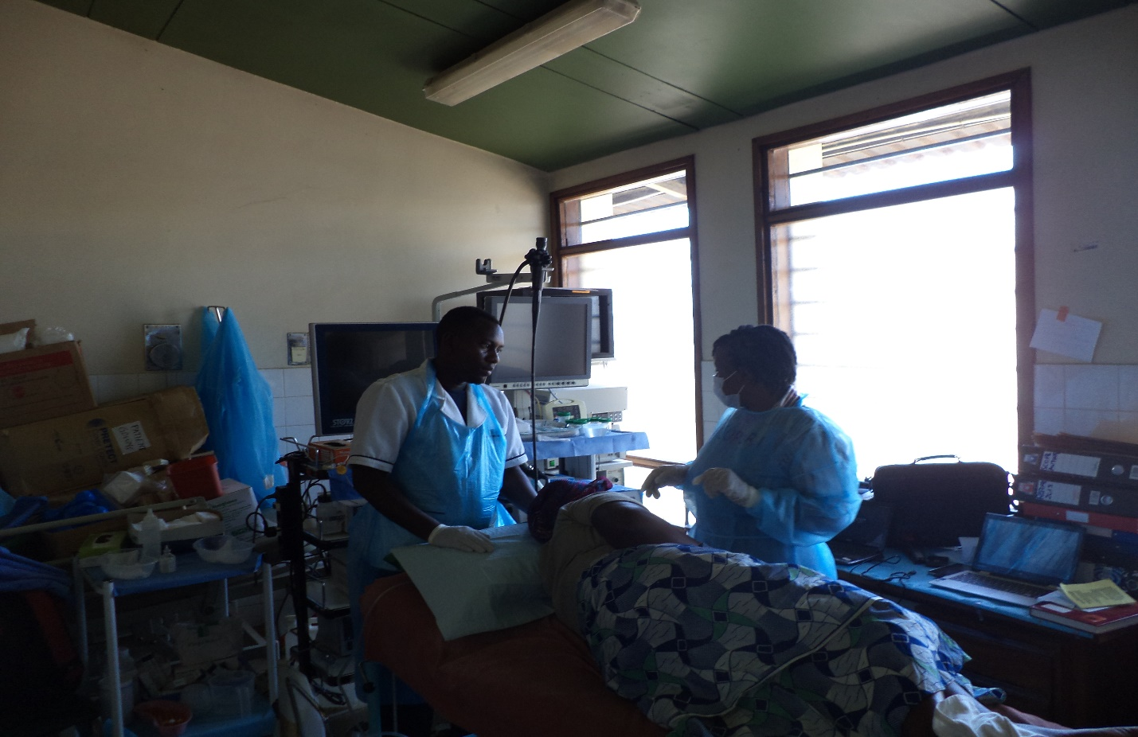

Preparing a patient for endoscopy in the A/E theatre endoscopy room

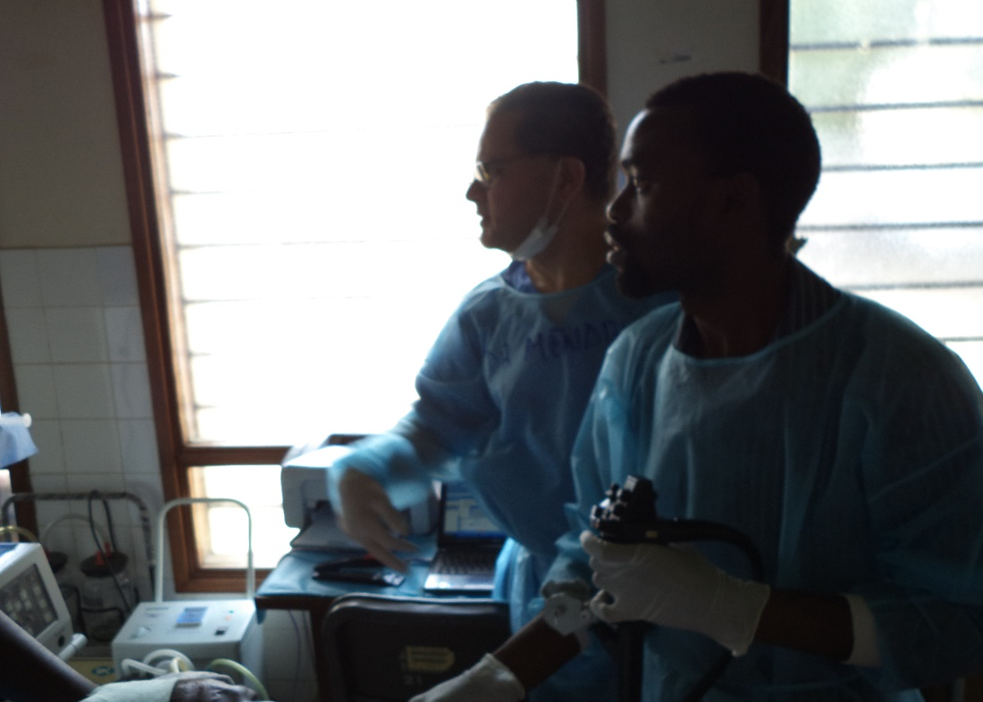Chifundo performing variceal band ligation

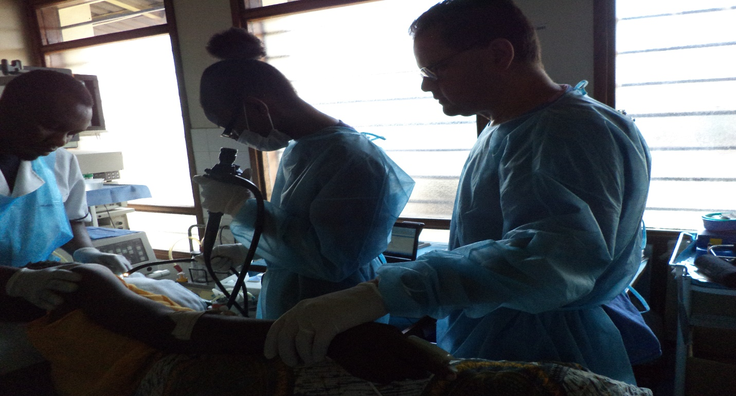

Training with Vanessa using a fibreoptic scope

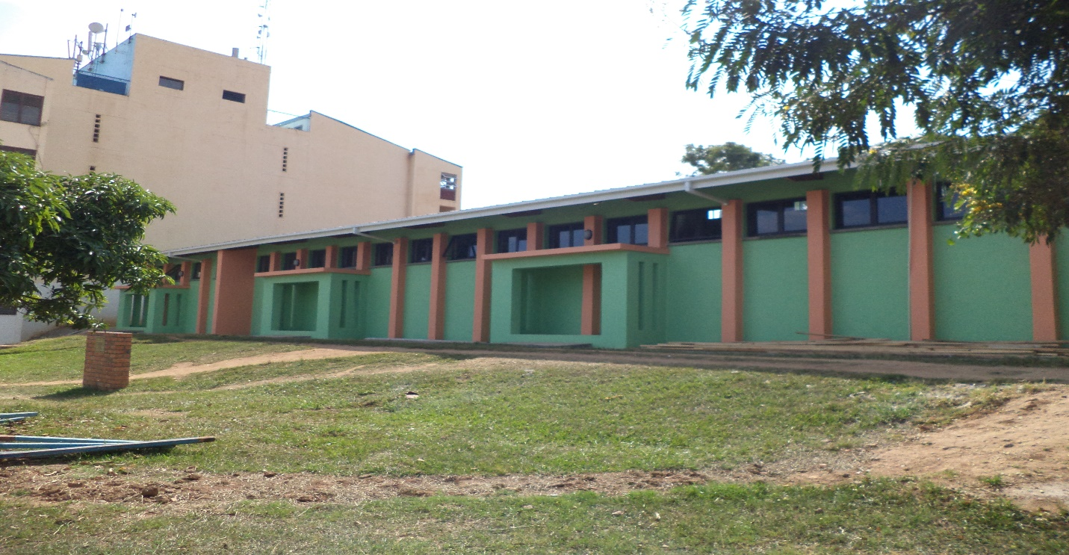

New HDU/ITU and endoscopy unit

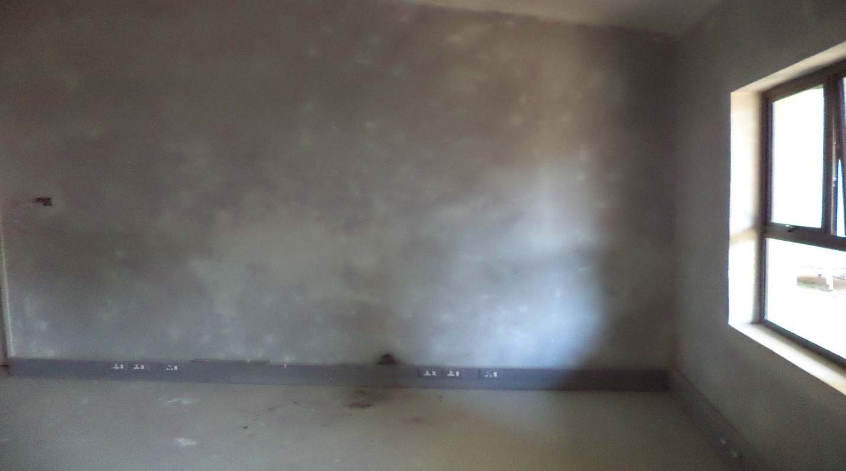

New endoscopy room

Estimated expenditure

Remaining funds from the BSG grant were used to cover the cost of the airline ticket( £610)

All other costs were covered by personal funds